DP World Sokhna Vessel Safety Pack

Welcome to our Terminal
Whilst your vessel is at our terminal we ask that you ensure that your crew and officers are aware of the procedures and protocols in place at this terminal.
These procedures and protocols are to help ensure the safety of all people working on and around your vessel. Any vessel working in DPW Sokhna waters must comply with our regulations.
Vessel safety inspections should be conducted with an authorised vessel representative e.g. first officer or duty officer. It will be noted on the vessel safety inspection if vessel is unrepresented.
In Case of Emergency

Please be advised in an event of an emergency on your vessel you are required to contact Sokhna Control Room, Control Tower, and the terminal operation supervisor as soon as possible.
When in communication with the Control Room team you will be required to provide the following information:
- Type of emergency?
- Where the emergency is?
- What happened?
- Are there any injuries?
- Medical assistance required?
- What is the extent of the emergency?
- If involving hazardous material provide UN no.?
Person in Charge

The operation supervisor / shift manager is the Person in Charge of all operations during your stay.
Operation Supervisor on Duty (PIC)
 | Number
Containers | 01094543333
GC&B | 01016215522
Planner | 01008559186
Control Room Numbers
+2 0102 223 9898
Safety Duty Phone
+201023498715
Emergency Duty Phone
+201010328477
Shift Details

DP World Sokhna works three, 8 hour shifts, 24 hours a day, 7 days a week. The shift start and finish are:
Shift | Day (1st) |  | Evening (2nd) |  | Midnight (3rd)
 | Start | Finish | Start | Finish | Start | Finish
Time | 08:00 | 16:00 | 16:00 | 00:00 | 00:00 | 08:00

Terminal Access and Visitor Bus

All crew must be aware of the terminal rules and protocols before leaving the vessel.
DP World Sokhna provides shuttle buses to transport people to and from the vessel 24/7.
Contact operations supervisor or a DP World Sokhna Security Officer assigned on the quay to call shuttle buses.
Important note: If unresponsive, the crew or passengers are to remain on the vessel deck clear of any working cranes.
All vessel crew, passengers and visitors must sign in and identify themselves at the main gate house before leaving the terminal or going to the vessel.
Vessel Presentation

Gangway
- Shall be secure and netted, prior to commencing work
- Shall provide access of at least 550mm width and 2 metres height.
- Kept fully lowered at all times.
- Must be kept clear of quay cranes at all times and not impede crane travel.
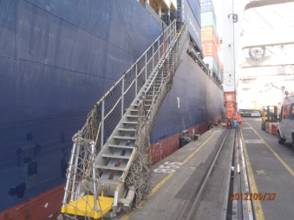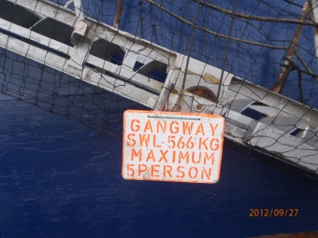
Gangway
Access between containers
- It is recommended that a working space be provided that is clear of all obstructions over a width of at least 550mm.
Walkways
- All walkways on a vessel shall be clear of obstructions.
- DP World terminals are strictly non-pedestrian areas, which mean no person is permitted to walk around the terminal. Terminal bus to be used at all times.
Fencing
- Any area that an employee is working in or likely to work in and is within 2 metres of an edge that could result in a fall of 2 metres must be fenced.
- Portable fences shall:
  - Be at least one metre high
  - Comprise of at least 2 parallel rails, ropes or chains kept taut
  - Be continuous
  - Be supported by metal stanchions not more than 2.5 metres part, which if fitted into sockets in the deck and must be secured in position (as per marine orders).
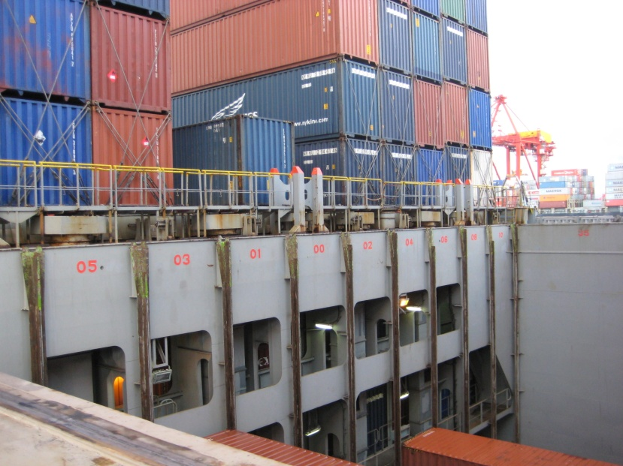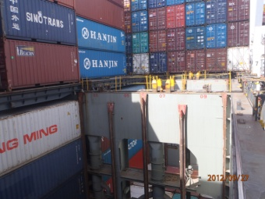
Vessel Fencing
Lighting
- Vessel is responsible for providing adequate lighting.
- Portable lighting shall be supplied and utilised as required.
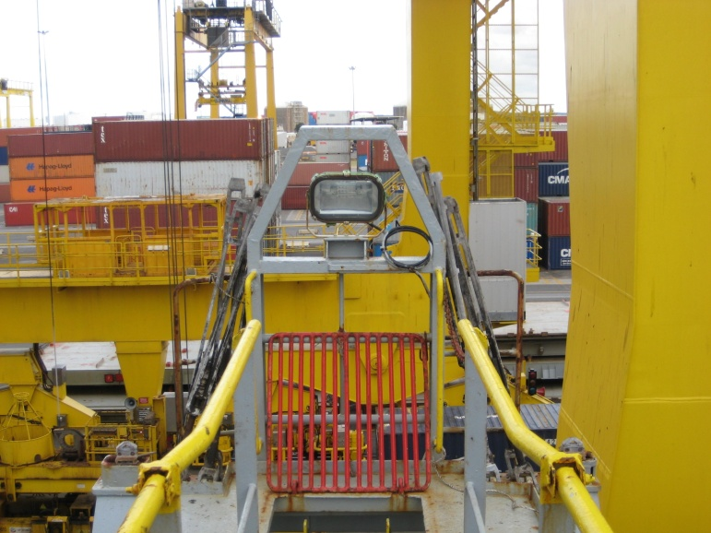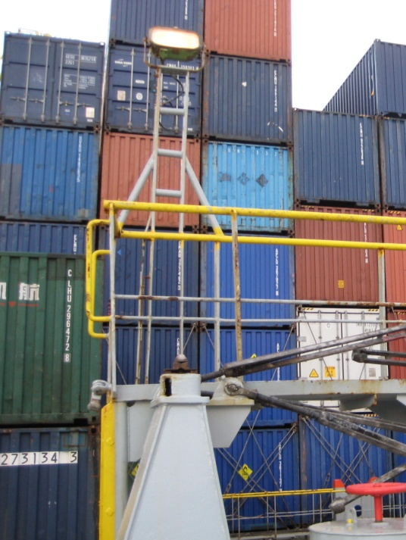
Vessel Lighting
Lashing
- An approved lashing plan shall be provided by the vessel.
- All outboard cells shall have adequate fall protection.
- Lashing bar can be handled using appropriate manual handling technique i.e. three-high, hi-cubes.

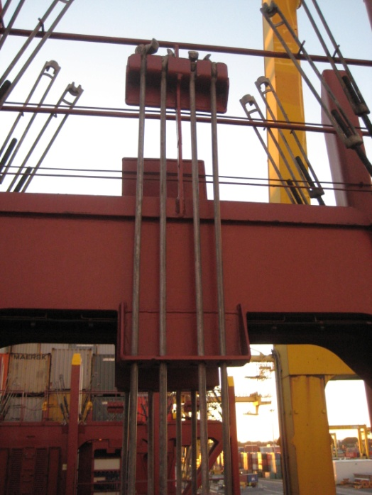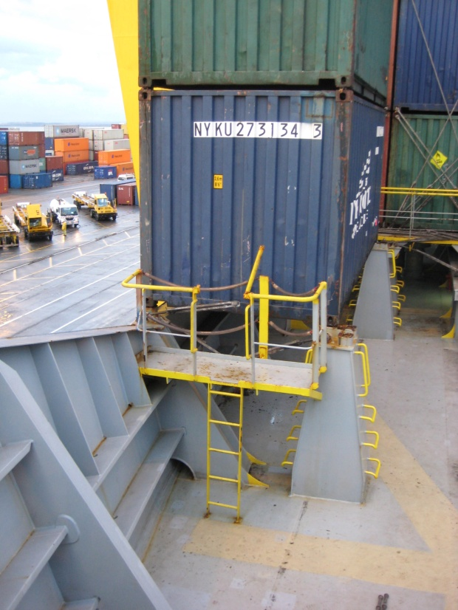
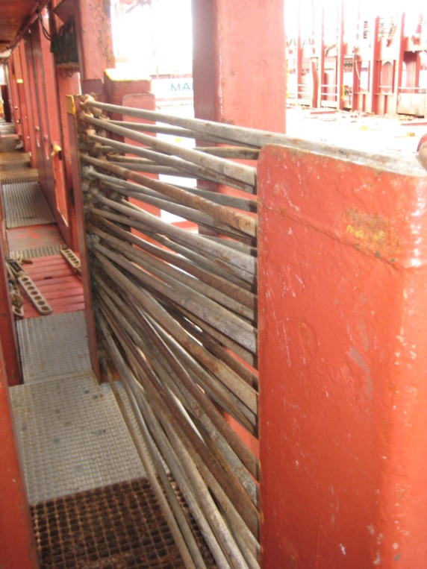
Stowage of Lashing Gear
Loading and discharge
- No person(s) shall work under an active crane arc whilst on board and ashore.
- Vessel crew shall ensure all reefer cables are clear of walkways and work areas.
- Vessel crew are responsible for unplugging / plugging reefers.
- Reefers must be isolated at the board in the vicinity of where lashing and unlashing operations are to be performed.
- Reefer cables of import boxes shall be unplugged & rolled up by crew and placed in the storage compartment of container before discharge.
- Mooring lines should always ensure the vessel is secure against the wharf and the lines should not impede crane travel.
- Testing of vessel engines alongside must have permission from Port Control Tower, DP World Sokhna Control Room and OPS supervisor/shift manager before commencing.
- Vessel engine testing shall not proceed while quay crane is operating over the vessel.
- Any crew wishing to access the wharf for inspection or maintenance of hatch covers must obtain permission to do so from the operation supervisor / shift manager.
- Vents or blowers may need to be turned off when persons are working nearby.
- Emissions from ship funnels should be minimised and only clean fuel burnt when in port to reduce the risk of fume exposure to DP World quay crane operators and the environment.
- Vessels shall notify the terminal and relevant authorities of all safety incidents (e.g. hazardous substance leaks), damage and structural non-conformities, prior to arrival or immediately after an incident.
- Any hazardous substance leaking containers shall only be discharged under direct approval and supervision from QHSE department.
- Cargo related issues are to be reported to the operation supervisor / shift manager.
Vessel crew
- Vessel crew are required to wear appropriate personal protective equipment (PPE) (high visibility clothing, hard hat, eye protection and safety footwear) adjacent to an active point of work on the vessel.
- Vessel crew shall not walk under suspended loads whilst aboard and ashore.
- Vessel crew are to abide by all terminal rules, as instructed in the vessel safety package.
- Any painting or paint chipping to be performed only with the permission from QHSE department. Any ship’s hull painting is not permitted in Sokhna. Drop net / sheets should be deployed, no paint or paint chips to enter the water or onto the wharf.
- The use of ship’s cranes or booms (in GC vessels) shall be notified to the DP World Sokhna operation supervisor / shift manager prior to their operation and they must be manned at all times when swung over the wharf.
- Prior notification and permission must be obtained by the vessel crew from the operation supervisor / shift manager for rubbish removal.
- Vessel command to request reefer and hazardous manifest from their local agent.
- All hot works are to be under a permit from QHSE department.
Vessel safety inspections
- Vessel safety inspections should be conducted with an authorised vessel representative e.g. first officer or duty officer. It will be noted on the vessel safety inspection if vessel is unrepresented.
- If an operation deficiency is not immediately rectified a Notice of Deficiencies (NOD) shall be issued to the vessel captain / officer in charge and local agent.

Environmental issues:
- It’s not allowed to Pint Vessel Hull, registration number and IMO number while the vessel is berthing on the quay side.
- Its not allowed to load paints or chemicals from Quay side and it is allowed only from seaside.
- If you need to discharge blast water, you should communicate first with DPW Sokhna QHSE team.

